Latihan SQL

**Petunjuk**

* Gunakan PhpMyAdmin yang terdapat pada komputer Anda atau [PhpMyAdmin versi online](https://demo.phpmyadmin.net/master-config/)
* Masukkan query Anda ke dalam textbox yang telah disediakan
* Screenshoot hasil query Anda sebagai bukti query Anda berhasil dieksekusi

1. Buatlah sebuah database dengan nama olshop\_nama\_anda

**CREATE DATABASE** olshop\_eko;

CREATE

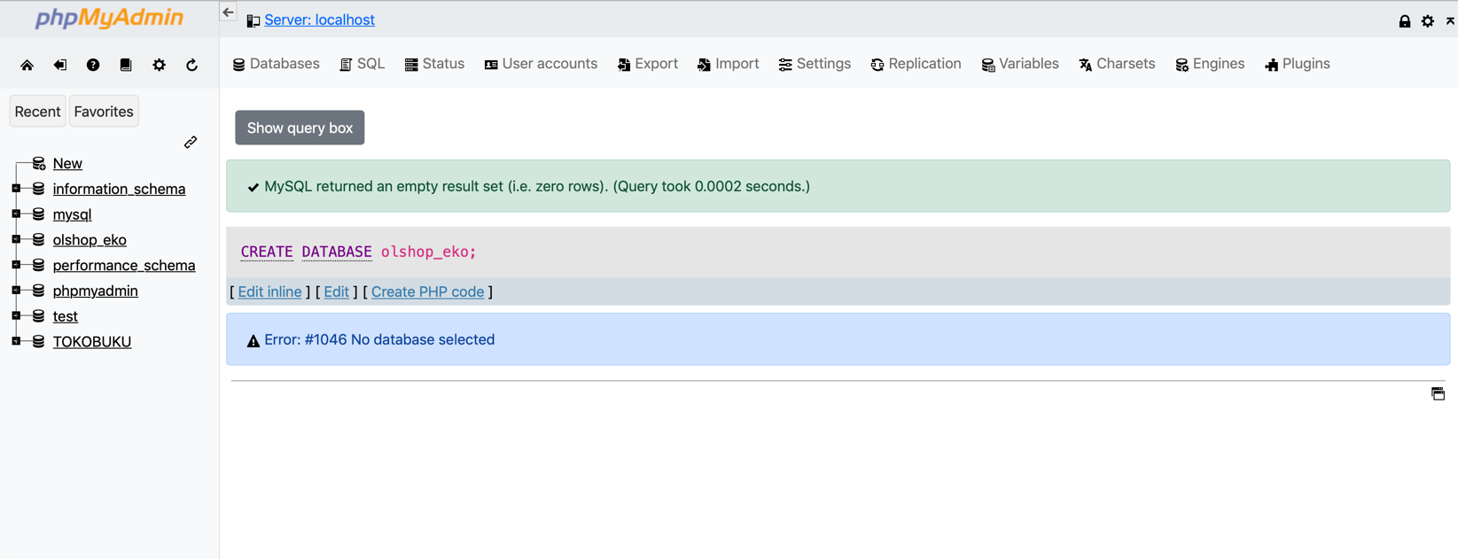**Screenshoot Hasil Query:**

1. Buatlah Tabel Pelanggan seperti contoh tabel dibawah ini

|  |  |  |  |  |  |  |
| --- | --- | --- | --- | --- | --- | --- |
| **pelanggan\_id** | **nama** | **email** | **password** | **tanggal\_lahir** | **alamat** | **kodepos** |
| 1 | Andi | andi@email.com | andi | 1971-02-19 | Tangerang | 1234 |
| 2 | Asih | asih@email.com | asih | 1973-05-02 | Padang | 1111 |
| 3 | Budi | budi@email.com | budi | 1975-06-29 | Padang | 1111 |
| 4 | Ari | ari@email.com | ari | 1977-10-04 | Pekanbaru | 1432 |
| 5 | Erni | erni@email.com | erni | 1989-02-23 | Depok | 1567 |
| 6 | Hesdey | hesdey@email.com | hesdey | 1988-12-16 | Depok | 1567 |

Membuat Tabel pelanggan:

[CREATE](http://localhost/phpmyadmin/url.php?url=https://dev.mysql.com/doc/refman/8.0/en/create-table.html" \t "mysql_doc) [TABLE](http://localhost/phpmyadmin/url.php?url=https://dev.mysql.com/doc/refman/8.0/en/create-table.html) pelanggan ( pelanggan\_id INTEGER [NOT](http://localhost/phpmyadmin/url.php?url=https://dev.mysql.com/doc/refman/8.0/en/logical-operators.html%23operator_not) NULL AUTO\_INCREMENT, namaVARCHAR(100) [NOT](http://localhost/phpmyadmin/url.php?url=https://dev.mysql.com/doc/refman/8.0/en/logical-operators.html%23operator_not) NULL, email VARCHAR(50) [NOT](http://localhost/phpmyadmin/url.php?url=https://dev.mysql.com/doc/refman/8.0/en/logical-operators.html%23operator_not) NULL, [password](http://localhost/phpmyadmin/url.php?url=https://dev.mysql.com/doc/refman/8.0/en/encryption-functions.html%23function_password) VARCHAR(255) [NOT](http://localhost/phpmyadmin/url.php?url=https://dev.mysql.com/doc/refman/8.0/en/logical-operators.html%23operator_not)NULL, tanggal\_lahir DATE [NOT](http://localhost/phpmyadmin/url.php?url=https://dev.mysql.com/doc/refman/8.0/en/logical-operators.html%23operator_not) NULL, alamat VARCHAR(255) [NOT](http://localhost/phpmyadmin/url.php?url=https://dev.mysql.com/doc/refman/8.0/en/logical-operators.html%23operator_not) NULL, kodeposVARCHAR(7) [NOT](http://localhost/phpmyadmin/url.php?url=https://dev.mysql.com/doc/refman/8.0/en/logical-operators.html%23operator_not) NULL, PRIMARY KEY (pelanggan\_id) );

Menambahkan data ke dalam table pelanggan:

INSERT INTO `pelanggan`

(`nama`, `email`, `password`, `tanggal\_lahir`, `alamat`, `kodepos`)

VALUES

('Andi', 'andi@email.com', 'andi', '1971-02-19', 'Tangerang', 1234),

('Asih', 'asih@email.com', 'asih', '1973-05-02', 'Padang', 1234),

('Budi', 'budi@email.com', 'budi', '1975-06-29', 'Padang', 1111),

('Ari', 'ari@email.com', 'ari', '1977-10-04', 'Pekanbaru', 1432),

('Erni', 'erni@email.com', 'erni', '1989-02-23', 'Depok', 1567),

('Hesdey', 'hesdey@email.com', 'hesdey', '1988-12-16', 'Depok', 1567);

**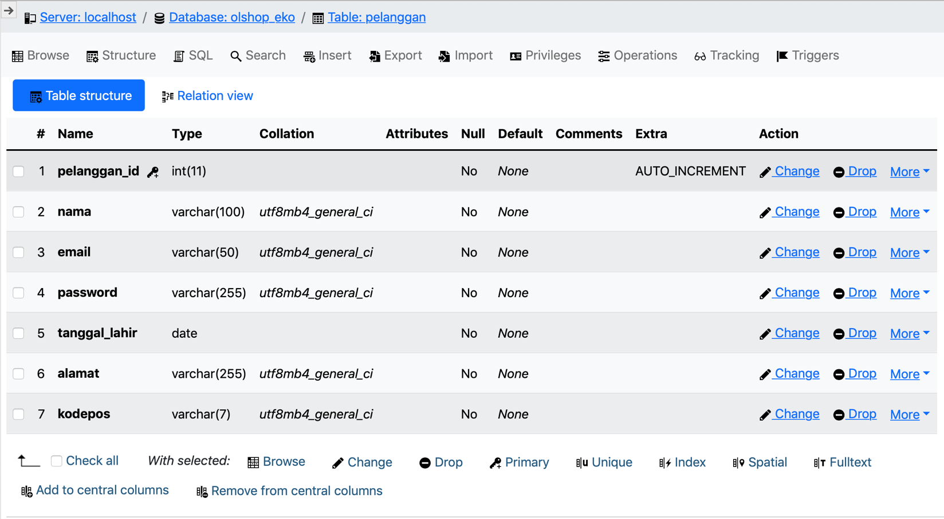Screenshoot Hasil Query**

**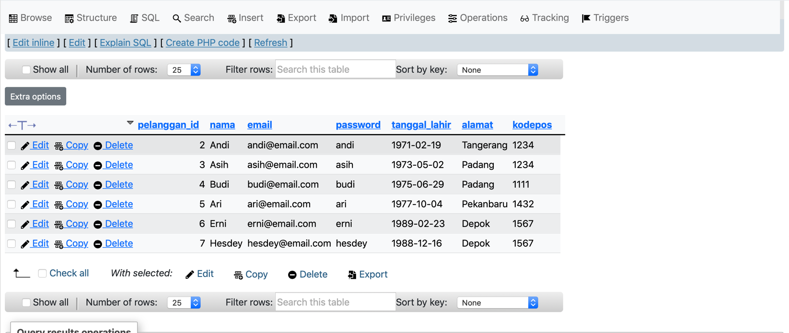**

1. Tampilkan semua pelanggan dengan kode pos = 1111

[SELECT](http://localhost/phpmyadmin/url.php?url=https://dev.mysql.com/doc/refman/8.0/en/select.html) \* FROM `pelanggan` WHERE `kodepos` = 1111;

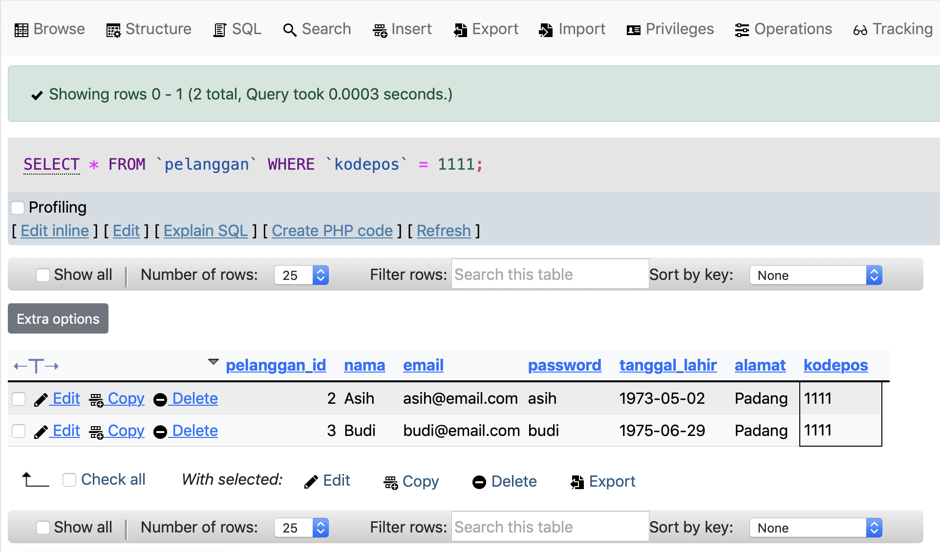 **Screenshoot Hasil Query**

1. Tampilkan nama dan tanggal lahir pelanggan yang tinggal di Depok

[SELECT](http://localhost/phpmyadmin/url.php?url=https://dev.mysql.com/doc/refman/8.0/en/select.html)

`nama`, `tanggal\_lahir`

FROM

`pelanggan`

WHERE

`alamat` = 'Depok';

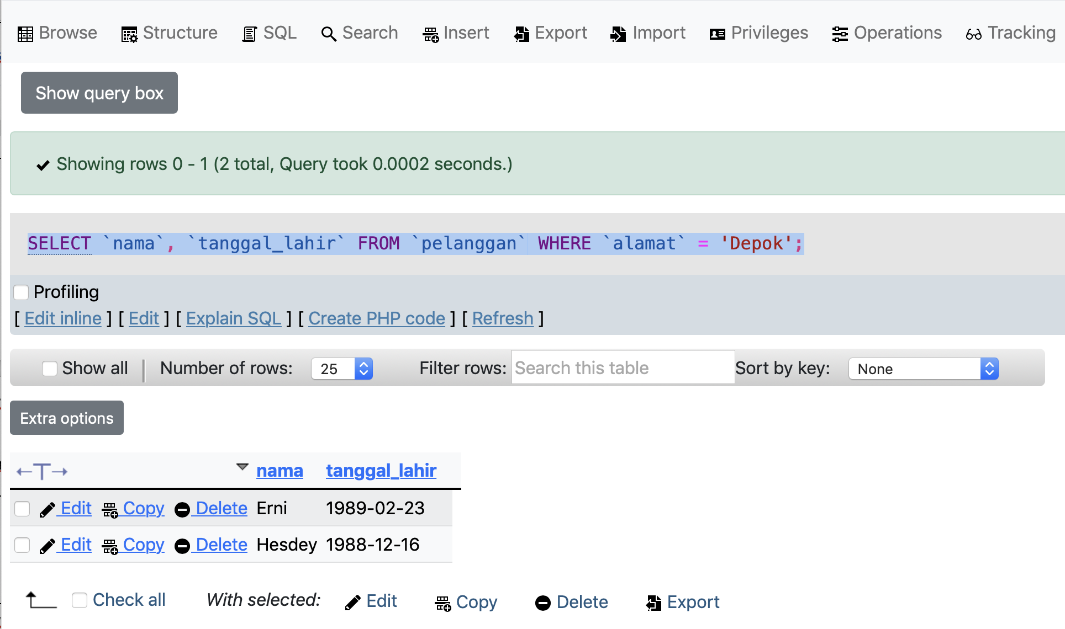**Screenshoot Hasil Query**

1. Tampilkan semua pelanggan terurut berdasarkan abjad

[SELECT](http://localhost/phpmyadmin/url.php?url=https://dev.mysql.com/doc/refman/8.0/en/select.html) \* FROM `pelanggan` ORDER BY `nama` ASC;

**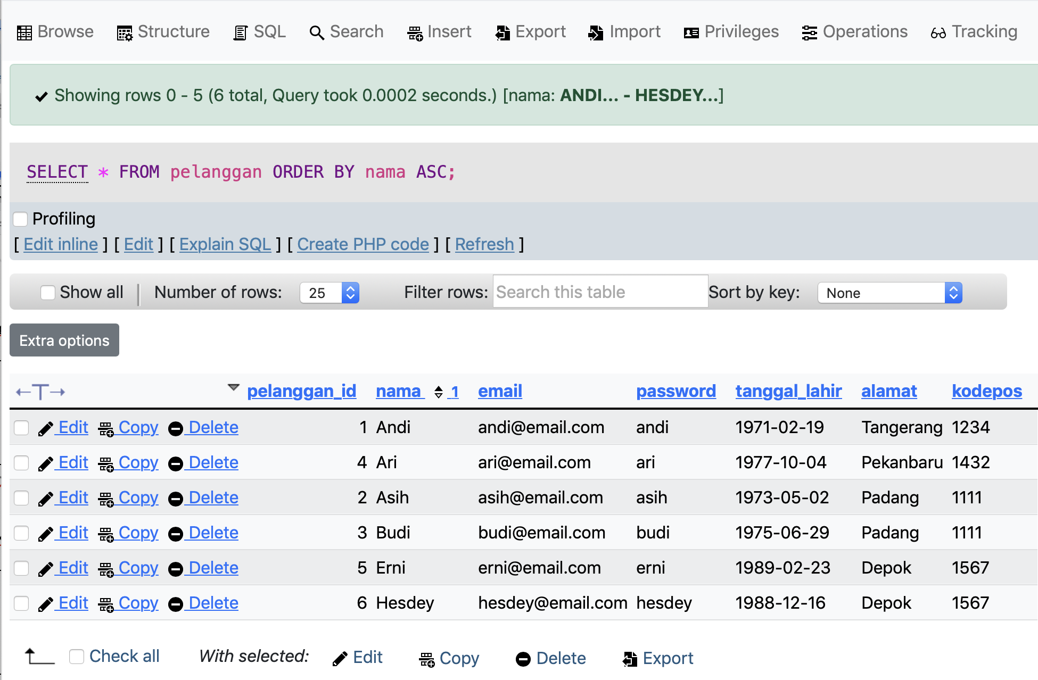Screenshoot Hasil Query**

1. Perbaharui alamat dan kode pos Andi menjadi Bandung dan 1919

[UPDATE](http://localhost/phpmyadmin/url.php?url=https://dev.mysql.com/doc/refman/8.0/en/update.html) `pelanggan` [SET](http://localhost/phpmyadmin/url.php?url=https://dev.mysql.com/doc/refman/8.0/en/set.html) `alamat` = 'Bandung', `kodepos` = '1919'

WHERE `pelanggan`.`pelanggan\_id` =1;

**Screenshoot Hasil Query:**

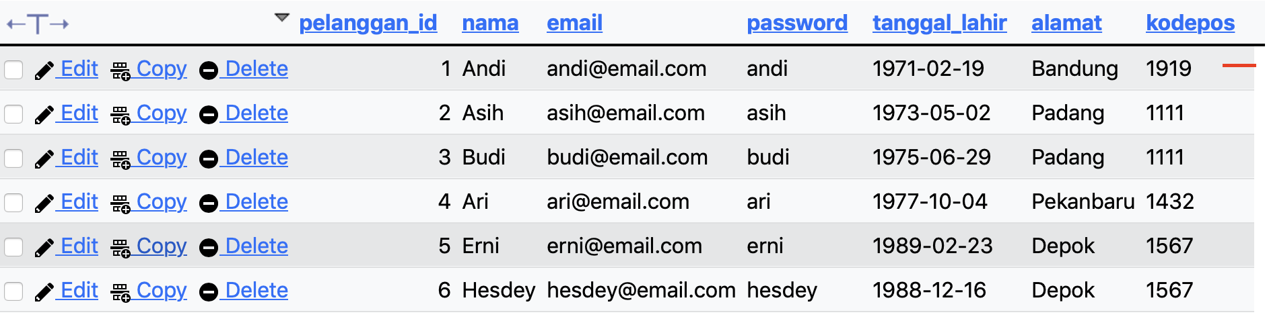

1. Tampilkan jumlah pelanggan

[SELECT](http://localhost/phpmyadmin/url.php?url=https://dev.mysql.com/doc/refman/8.0/en/select.html) [COUNT](http://localhost/phpmyadmin/url.php?url=https://dev.mysql.com/doc/refman/8.0/en/aggregate-functions.html%23function_count)(\*) AS Jumlah\_Pelanggan FROM pelanggan;

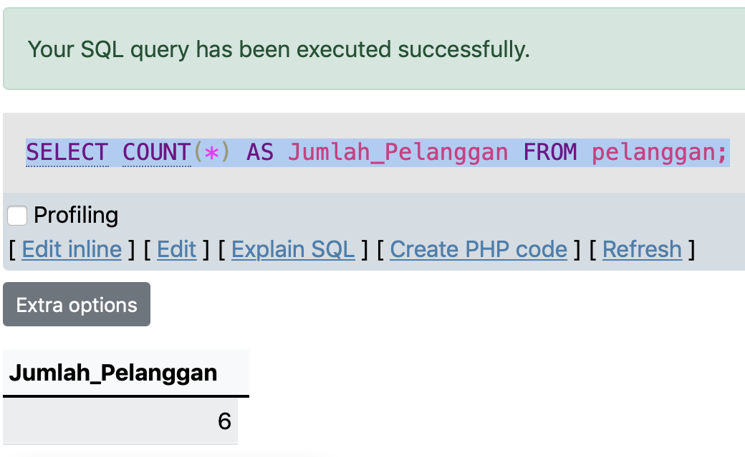**Screenshoot Hasil Query**

1. Hapus pelanggan yang bernama Erni

[DELETE](http://localhost/phpmyadmin/url.php?url=https://dev.mysql.com/doc/refman/8.0/en/delete.html) FROM pelanggan WHERE nama='Erni';

**Screenshoot Hasil Query:**

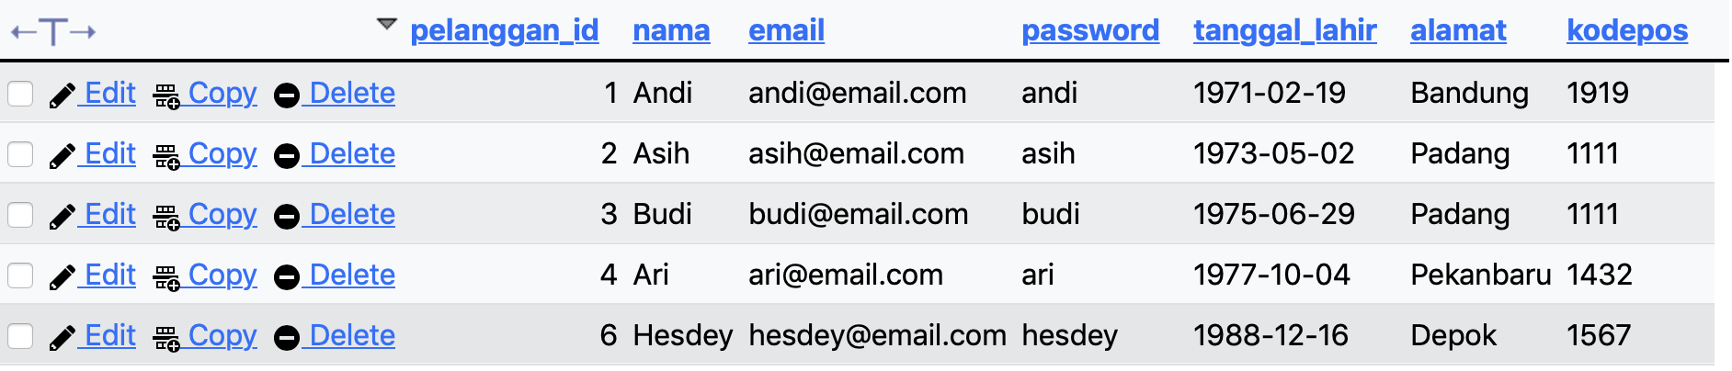

1. Buatlah Tabel Produk seperti tabel dibawah ini

|  |  |  |  |  |  |
| --- | --- | --- | --- | --- | --- |
| **produk\_id** | **nama** | **sku** | **stok** | **harga\_satuan** | **img\_url** |
| 1 | Produk Satu | PRD023 | 10 | 1000 | ../assets/image/product/prd023 |
| 2 | Produk Dua | PRD024 | 15 | 3000 | ../assets/image/product/prd024 |
| 3 | Produk Tiga | PRD025 | 112 | 11000 | ../assets/image/product/prd025 |
| 4 | Produk Empat | PRD026 | 5 | 45000 | ../assets/image/product/prd026 |
| 5 | Produk Lima | PRD027 | 50 | 7000 | ../assets/image/product/prd027 |
| 6 | Produk Enam | PRD028 | 0 | 500 | ../assets/image/product/prd028 |

--Membuat table produk

CREATE TABLE `produk`(

`produk\_id` INTEGER NOT NULL AUTO\_INCREMENT,

`nama` VARCHAR(100) NOT NULL,

`sku` VARCHAR(50) NOT NULL,

`stok` INTEGER NOT NULL,

`harga\_satuan` DECIMAL(7.2) NOT NULL,

`img\_url` VARCHAR(255) NOT NULL,

PRIMARY KEY(`produk\_id`)

);

--Memasukkan data ke dalam table produk

INSERT INTO `produk` (`nama`, `sku`, `stok`, `harga\_satuan`, `img\_url`)

VALUES

('Produk Satu', 'PRD023', 10, 1000, '../assets/image/product/prd023'),

('Produk Dua', 'PRD024', 15, 3000, '../assets/image/product/prd024'),

('Produk Tiga', 'PRD025', 112, 11000, '../assets/image/product/prd025'),

('Produk Empat', 'PRD026', 5, 45000, '../assets/image/product/prd026'),

('Produk Lima', 'PRD027', 50, 7000, '../assets/image/product/prd027'),

('Produk Enam', 'PRD028', 0, 500, '../assets/image/product/prd028');

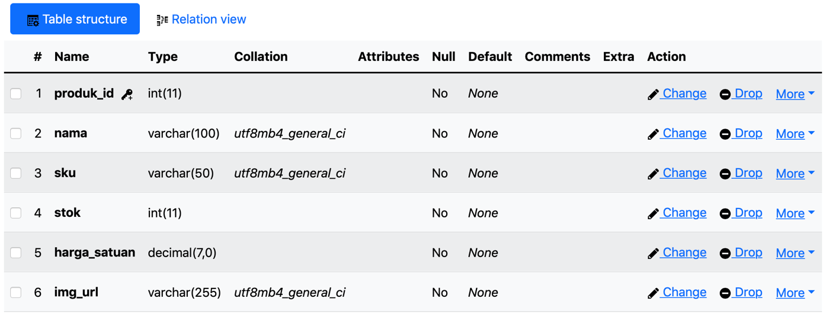**Screenshoot Hasil Query**

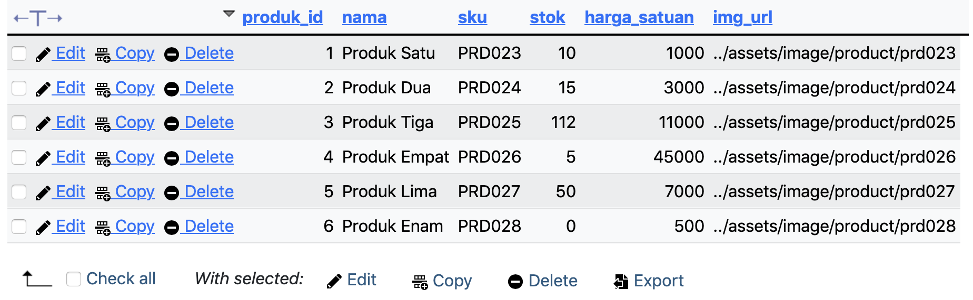

1. Tampilkan produk yang harga satuannya antara 5000 s/d 50000

[SELECT](http://localhost/phpmyadmin/url.php?url=https://dev.mysql.com/doc/refman/8.0/en/select.html) \* FROM `produk` WHERE `harga\_satuan` BETWEEN 5000 [AND](http://localhost/phpmyadmin/url.php?url=https://dev.mysql.com/doc/refman/8.0/en/logical-operators.html%23operator_and) 50000;

**Screenshoot Hasil Query:**

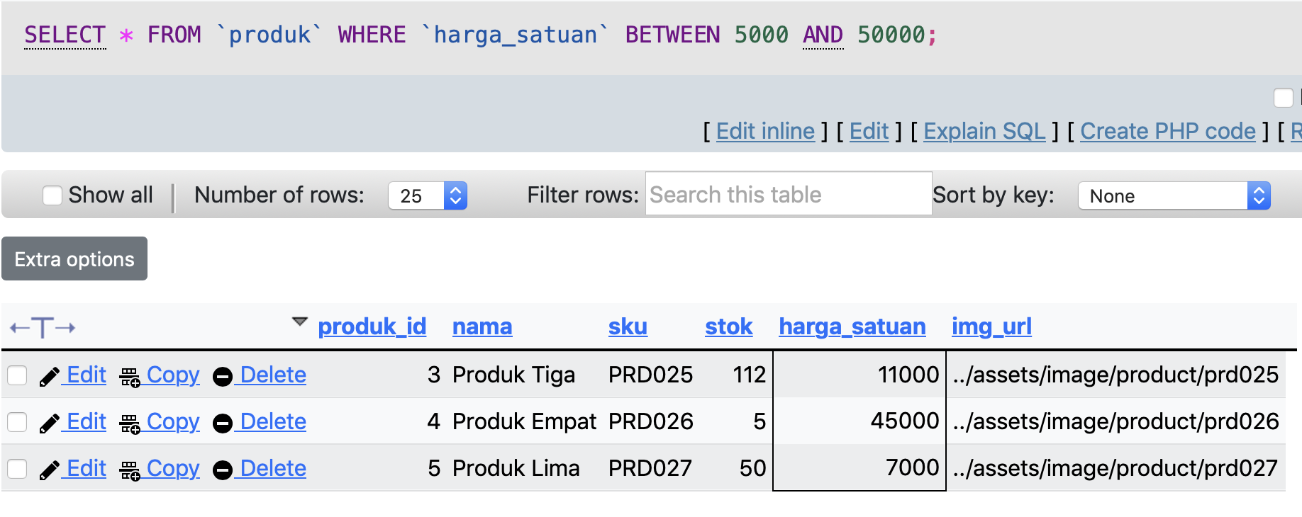

1. Tampilkan produk yang stok barangnya lebih kecil dari 20

[SELECT](http://localhost/phpmyadmin/url.php?url=https://dev.mysql.com/doc/refman/8.0/en/select.html) \* FROM produk WHERE stok < 20;

**Screenshoot Hasil Query**

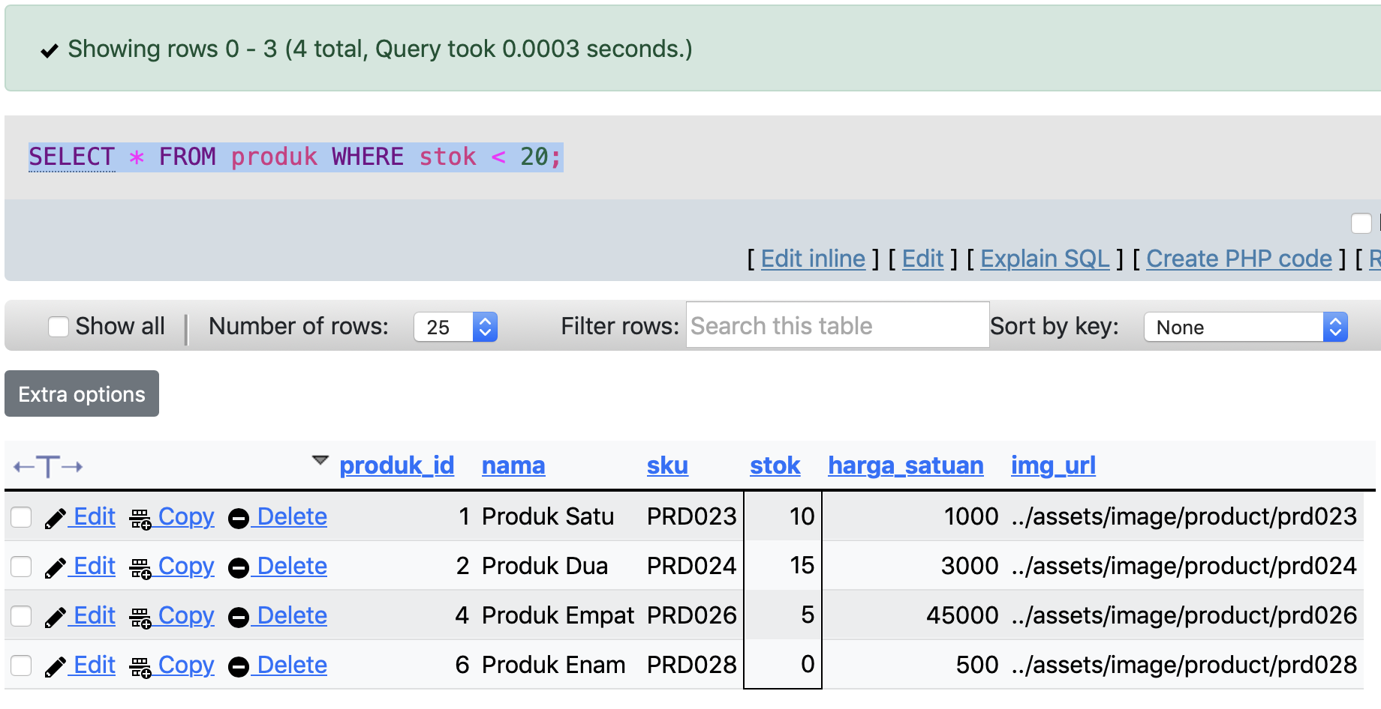

1. Tampilkan produk dengan harga satuan tertinggi dan harga satuan terendah

[SELECT](http://localhost/phpmyadmin/url.php?url=https://dev.mysql.com/doc/refman/8.0/en/select.html) produk\_id, nama, harga\_satuan AS HargaTerendah FROM produk

WHERE harga\_satuan [IN](http://localhost/phpmyadmin/url.php?url=https://dev.mysql.com/doc/refman/8.0/en/comparison-operators.html%23function_in) ([SELECT](http://localhost/phpmyadmin/url.php?url=https://dev.mysql.com/doc/refman/8.0/en/select.html) [MIN](http://localhost/phpmyadmin/url.php?url=https://dev.mysql.com/doc/refman/8.0/en/aggregate-functions.html%23function_min)(harga\_satuan) FROM produk);

[SELECT](http://localhost/phpmyadmin/url.php?url=https://dev.mysql.com/doc/refman/8.0/en/select.html) produk\_id, nama, harga\_satuan AS HargaTertinggi FROM produk

WHERE harga\_satuan [IN](http://localhost/phpmyadmin/url.php?url=https://dev.mysql.com/doc/refman/8.0/en/comparison-operators.html%23function_in) ([SELECT](http://localhost/phpmyadmin/url.php?url=https://dev.mysql.com/doc/refman/8.0/en/select.html) [MAX](http://localhost/phpmyadmin/url.php?url=https://dev.mysql.com/doc/refman/8.0/en/aggregate-functions.html%23function_max)(harga\_satuan) FROM produk);

**Screenshoot Hasil Query:**

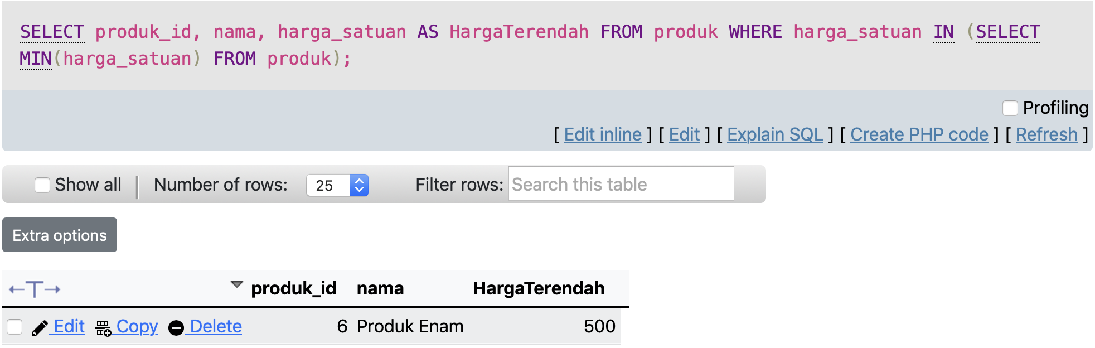

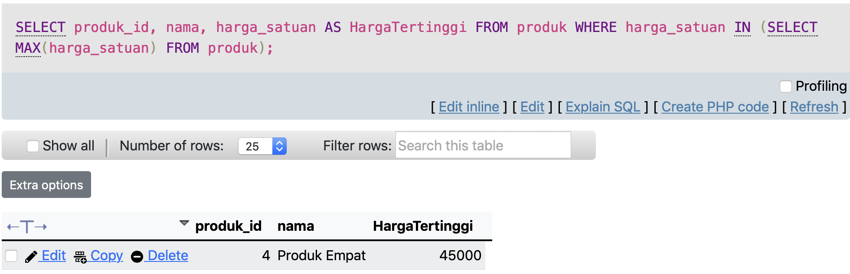

1. Tampilkan (hanya) tiga produk berdasarkan stok terbanyak

[SELECT](http://localhost/phpmyadmin/url.php?url=https://dev.mysql.com/doc/refman/8.0/en/select.html) \* FROM `produk` ORDER BY `stok` DESC LIMIT 3;

**Screenshoot Hasil Query:**

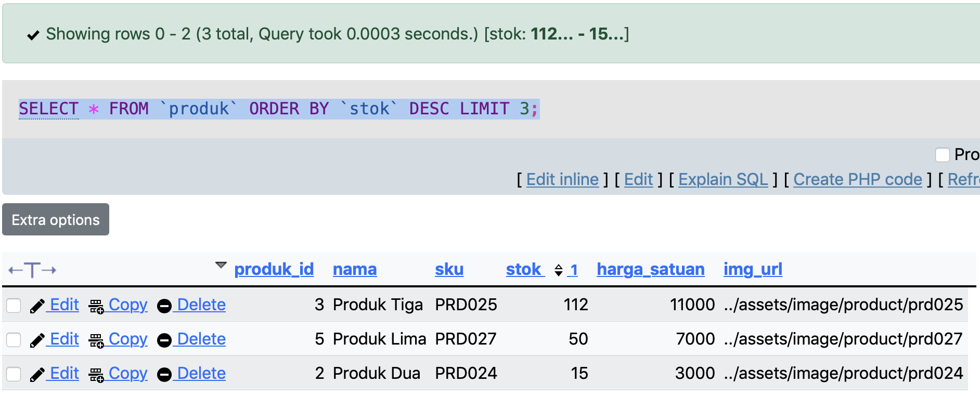

1. Tampilkan jumlah produk

[SELECT](http://localhost/phpmyadmin/url.php?url=https://dev.mysql.com/doc/refman/8.0/en/select.html) [COUNT](http://localhost/phpmyadmin/url.php?url=https://dev.mysql.com/doc/refman/8.0/en/aggregate-functions.html%23function_count)(`produk\_id`) AS JumlahProduk FROM `produk`;

**Screenshoot Hasil Query:**

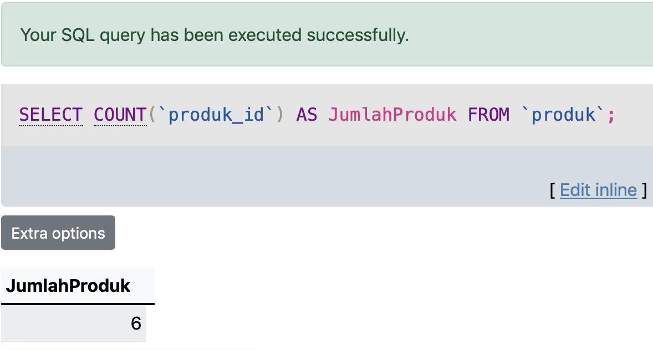

1. Perbaharui jumlah stok Produk Tiga menjadi 100 item

[UPDATE](http://localhost/phpmyadmin/url.php?url=https://dev.mysql.com/doc/refman/8.0/en/update.html) produk [SET](http://localhost/phpmyadmin/url.php?url=https://dev.mysql.com/doc/refman/8.0/en/set.html) stok = 100 WHERE produk\_id='3';

**Screenshoot Hasil Query**

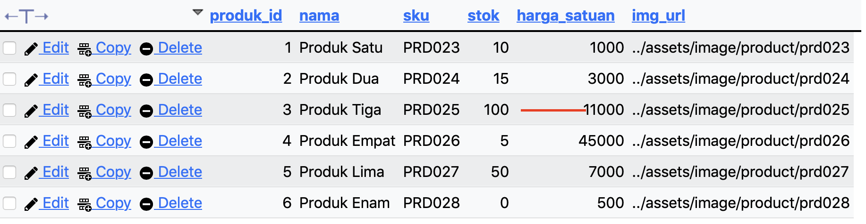

1. Hapus sebuah produk dengan nama Produk Enam

[DELETE](http://localhost/phpmyadmin/url.php?url=https://dev.mysql.com/doc/refman/8.0/en/delete.html) FROM produk WHERE produk\_id='6';

**Screenshoot Hasil Query:**

